KAMPALA JUNIOR ACADEMY – KITANTE
P.2 ENGLISH TERM I 2020

NAME: ___________________________________________STREAM: _______
WEEK ONE
OUR SCHOOL AND NEIGBOURHOOD
1. Fill in the missing letters.
a) d___st (b) br___ ____m (c) m___ney
d) un___fo___m (e) m___dic___ne (f) tr____ ____
2. What is this/ that?
NANO PRIMARY SCHOOL
a) That is a ________________.
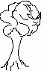
b) This is a _______________.

c) This is a ______________.


3. Answer Yes, they are. or No, they are not.
a) Are these dresses?
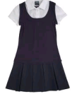
__________________________________________
b) Are those uniforms?
__________________________________________

c) Are these books?
________________________________________
4. Use the words in the box to complete the sentences.
under , between , over , near, behind
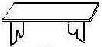
a) The bench is __________________the tree.
b) The aeroplane is flying ____________the hill.

c) The stone is _____________________the tines.
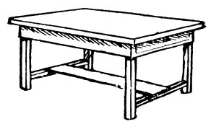

d) The flower is _____________the table.

5. Re-arrange these words to make correct sentences.
a) gun is That. ___________________________________________
b) helping others I like. __________________________________
c) is running The policeman. ________________________________
6. Ring the odd word out.
a) cat, sheep , house, cow
b) mother, chalk, father, sister
7. Write the plural form of the words below.
a) child _____________ b) money ________________
c) policeman ____________________
8. Give the answers in words.
a) Two bundles of ten sticks makes ________________(20)
b) There are ____________girls in the class. (15)
c) A dozen has ______________things. (12)
9. Fill in is or are in the gaps.
a) There _____________a church in our neighbourhood.
b) There _______________seven balls in the house.
c) There _______________man in the compound.

WEEK TWO
OUR HOME AND COMMUNITY
1. Give the opposite of the underlined word.
a) Are you my father? _______________________
b) She is my niece. ________________________
c) Aunt went to town yesterday. ______________
2. Fill in the correct information required.
My name is __________________. My father’s name is
Mr. ________________ and my mother’s name is Mrs. _______________. I have sisters and _______________brothers.

3. Choose the correct word from the brackets to complete the sentences.
a) Mary is six ___________old. (ears, years)
b) Seven days make a _______________. (week , weak)
c) This is ______________. (son sun)
4. Use the verb in brackets to fill the gaps.
a) A fisherman _______________fish everyday. (catch)
b) Mother __________________food yesterday. (cook)
c) A carpenter is _________________a table. (make)
d) I _______________my homework every weekend. (do)
e) We are ________________the compound. (sweep)
5. Arrange in alphabetical order.
a) doctor, farmer, cook, teacher
_________________________________________________________
b) hat, uniform, gomesi, skin
_________________________________________________________
6. Write the following in full.
a) Dr. _____________________ (b) can’t ________________
c) Rev. ____________________ (d) don’t ________________
7. Use have or has to fill the gaps.
a) We _____________no chairs in class.
b) He ________________a beautiful shirt.
c) Mummy ________________long hair.
8. Read and draw pictures.
a) The girls are skipping a rope. b) The teacher is teaching.

9. Read the story and answer the questions in full sentences.
MY FRIEND
My friend’s name is Fatuma. She is in Primary Two. She goes to the market every Saturday. She buys paw paws, mangoes and oranges. She eats potatoes, beans and pineapples on Sunday. This food makes her healthy.
Questions
a) Who is in Primary Two?
________________________________________________________
b) When does Fatuma go to the market?
________________________________________________________
c) What does Fatuma eat on Sunday?
________________________________________________________
d) Write two things (fruits) Fatuma buys from the market.
(i) ________________________ (ii) ____________________
e) Write the singular word for;-
oranges _________________________________
WEEK THREE
HUMAN BODY AND HEALTH
1. Fill in the missing letters.
a) stom____ ___ch (b) fin___er
c) e____e (d) l___gs
2. Form small words from the big ones.
a) monkey _______________ ______________
b) fingers _______________ ______________
3. Re-write the sentences giving the plural form of the underlined words.
a) My knee is bleeding.
_______________________________________________________
b) Musa has a long fingernail.
_________________________________________________________
c) Her hair is black.
_________________________________________________________
4. Circle the odd man out.
a) eye, nose, pig, ear
b) book, rubber, policeman , ruler
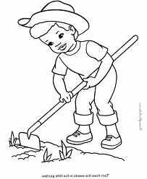
5. Answer these questions correctly.
a) What is he doing?
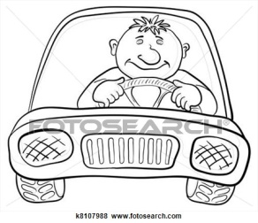
_________________________________________
b) What is he doing?
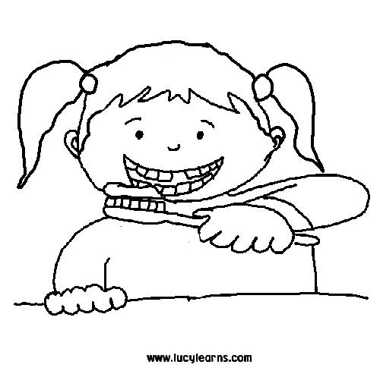
_________________________________________
c) What is she doing?
_________________________________________
6. Give one word for the underlined group of words.
a) I have eyes, hands and legs.
_________________________________________________________
b) Tom, Herbert and Peter are sick.
_________________________________________________________

7. Choose a correct word from the box below to complete the sentences.

mop, smart, sweep, toothbrush, soap, water , nail cutter
We are good children at school. Good children look ______________all the time. We need _________________and ________________to bathe. Bathing helps us be clean and healthy.

We brush our teeth using a _________________and cut nails using a __________________. Before going to school, we ________________ and ___________________our room. We are very good children.

8. Punctuate these sentences correctly.
a) What is your name?
________________________________________________________
b) Kampala I live in
_______________________________________________________
9. Read the rhyme below and answer the questions correctly.
Two little black birds, sitting on the wall,
One names Peter,
One names Paul,
Fly away Peter,
Fly away Paul,
Come back Peter!
Come back Paul!
And sit on the wall.
Questions
a) What colour are the birds?
______________________________________________________
b) Where are the birds sitting?
______________________________________________________
c) Mention the names of the birds?
______________________________________________________
d) Who flew away first?
_______________________________________________________
e) What is the title of the rhyme?
_______________________________________________________
10. As white as ______________________. (Complete correctly)

WEEK FOUR
FOOD AND NUTRITION
1. Write these words correctly.
a) dofo _______________ (b) pwapaw ________________
c) mlik ________________ (d) yma _____________________

2. Form one word.
a) chalk+board = ______________________________
b) gum+boots = ______________________________
c) rain+ coat = ______________________________

3. Re-write the sentences giving the opposite of the underlined words.
a) My mangoes are big.
________________________________________________________
b) That cow is fat.
_________________________________________________________
c) My mother is sad.
________________________________________________________
4. Fill in the gaps with ‘has’ or ‘have’
a) John ______________a new bag.
b) We _________________many teachers in our school.
c) Benjamin ____________________two hands.
5. Arrange the sentences below to form a good story.
a) She fell down and broke her arm.
b) One day, Babirye and Kato were going to the market.
c) Babirye got scared and ran away.
d) They saw a big snake.
e) Babirye got a stick and hit its head.
A good story
a) _______________________________________________________
b) _______________________________________________________
c) _______________________________________________________
d) ______________________________________________________
e) _______________________________________________________

6. Change the words in brackets to a correct form to complete the sentences.
a) Sam _________________pineapples every holiday. (plant)
b) Mother is __________________in the garden. (dig)
c) The birds are ___________________. (whistle)
d) She _______________to Church every Sunday. (go)
e) They are ________________the school anthem. (sing)
7. Study the diagrams below and answer the questions correctly.
Monday | Tuesday
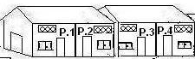

Wednesday | Thursday
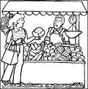  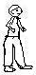 | 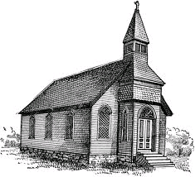

Questions
a) What does John do every Monday?
_______________________________________________________
b) What does John do every Thursday?
________________________________________________________
c) Where does John go every Tuesday?
________________________________________________________
d) Where does John go every Wednesday?
________________________________________________________
8. Construct meaningful sentences from the table below.
I  They  We | am  are | very sick.  going to church.  digging.

a) _________________________________________________________
b) _________________________________________________________
c) _________________________________________________________
9. I am ___________________years old. (Answer correctly)
10. I have a pen. I have a book.
Join the sentences using; ………and………….)
_________________________________________________________

